**DATABASE Design**

1. **Customer**

|  |
| --- |
| **Customer** |
| * **Name** * **Age**      * **Gender**      * **Nation**      * **Email ID** * **Phone Number** |

1. **Packages**

|  |
| --- |
| **Packages** |
| * **package ID** * **Source** * **Destination** * **Flight Information** |

**3. Billing**

|  |
| --- |
| **Billing** |
| * **Bill id** * **Customer name**      * **Guide Cost** * **Ticket cost** * **Cab cost** * **Room cost ac/Non ac** * **Food Cost veg/non-veg** * **Service cost** * **Total bill** |

**Architecture diagram**

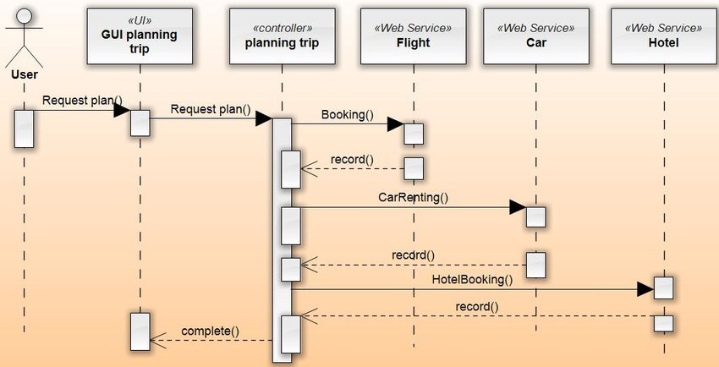

**UML Diagram**

1. **Class Diagram**

|  |
| --- |
| **Customer** |
| * **Name** * **Age** * **Gender** * **Nation** * **Email ID** * **Phone Number** |

|  |
| --- |
| **Packages** |
| * **package ID** * **Source** * **Destination** * **Flight Information** |

|  |
| --- |
| **Billing** |
| * **Bill id** * **Customer name** * **Guide Cost** * **Ticket cost** * **Cab cost** * **Room cost ac/Non ac**      * **Food Cost veg/non-veg** * **Service cost** * **Total bill** |

1. **Use-case Diagram**